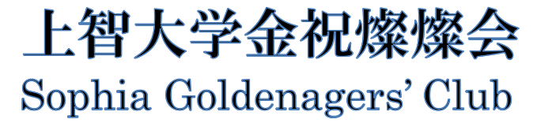

Application Form
for the 9th Japanese Speech Contest on May 28th, 2023

Please submit your application by e-mail to sansankai@sophiakai.gr.jp
by Sunday, May 14, 2023 (to be received by midnight).

カタカナkatakana  Full name 姓名 | ___________ ___________ ___________  First name Middle name Family name
Student ID Number 学籍番号
Faculty 学部学科
Gender 性別 (optional)
Nationality 国籍
Number of years studying Japanese
日本語学習年数
E-mail addressメールアドレス
Phone (Mobile) 携帯電話番号
Title of your speech 演題
Summary of your speech (in Japanese or English) スピーチの要約：
Note: The information you entered will be used for administrative purpose only by Sophia Goldenagers’ Club（上智大学金祝燦燦会）and not for other purposes.

